USER MANUAL

Welcome Page:

When you first open the webpage, you will be greeted with a welcome page showing you what this website is about. Here you can navigate to the register page when you can make your account and join the skills build player base or if you are an existing user, you can navigate to the log on page.

Figure 1- shows the welcome page

Register and log on:

The user here can register as a new user to join the skills build community. On the register page the user can decide a user name and create a password and once done will be redirected to the log on page.

Figure 2- shows the register page with user "Moksh" registering

On the log on page the user must enter their specific user name and password In order to access the rest of the website.

Figure 3- shows the log on page

Dashboard:

Once logged on the user is directed to the dashboard page. This serves as the main page on the website where you can access all the other pages shown in the navigation bar under the “IBM SKILLSBUILD COURSES” logo. The user can see a list of available courses to start and their specific category.

Figure 4- shows the dashboard with available courses

The user can also sort the list of courses in alphabetical order, reverse alphabetical order and by category to make it as simple as possible to find the course they want to start.

Figure 5- shows the courses sorted by category.

When you wish to see the status of the progress of a course, you can go to that page or if you wish to record your completion you can press the complete link.

Figure 6- shows the status link and the complete link.

Start Courses:

Active Courses Section:

* The page displays a list of active courses along with their elapsed time.
* Users can see the list of active courses in an ordered list, where each course is

displayed within a list item.

Start Session Form:

* Users can start a new course session by filling out the form.
* The form includes an input field for the course name.
* The user needs to enter the course name, and upon submitting the form.

Pause Session Form:

* Users can pause an active course session by choosing a course from the drop-

down list and submitting the form.

* This form includes a drop-down list which has the available courses.

Resume Session Form:

* Users can resume a paused course session by choosing a course from the drop-

down list and submitting the form.

* Like the “Pause Session” form, this form includes a drop-down list populated with available courses.

Footer Section:

* The footer includes social media links to IBM’s Instagram and Facebook pages.

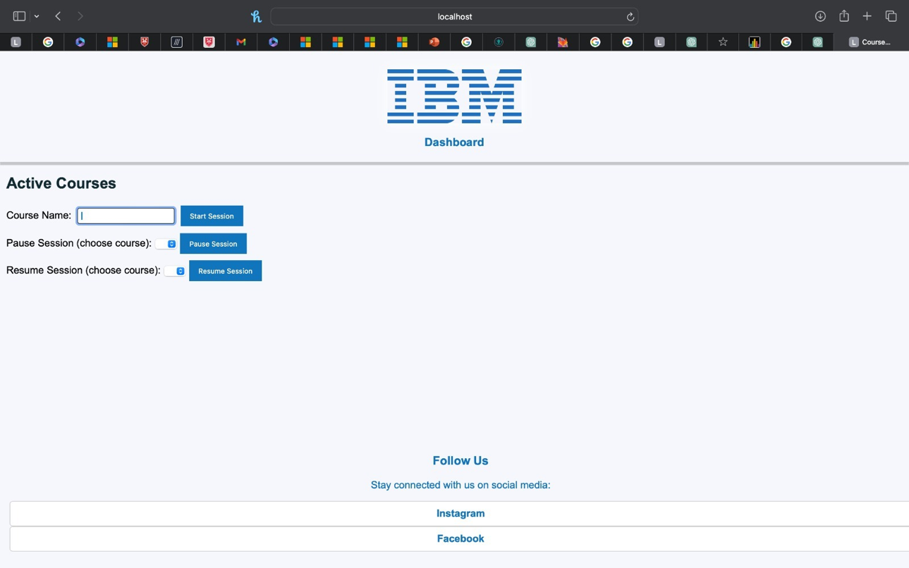

Figure 7- shows what the page looks like.

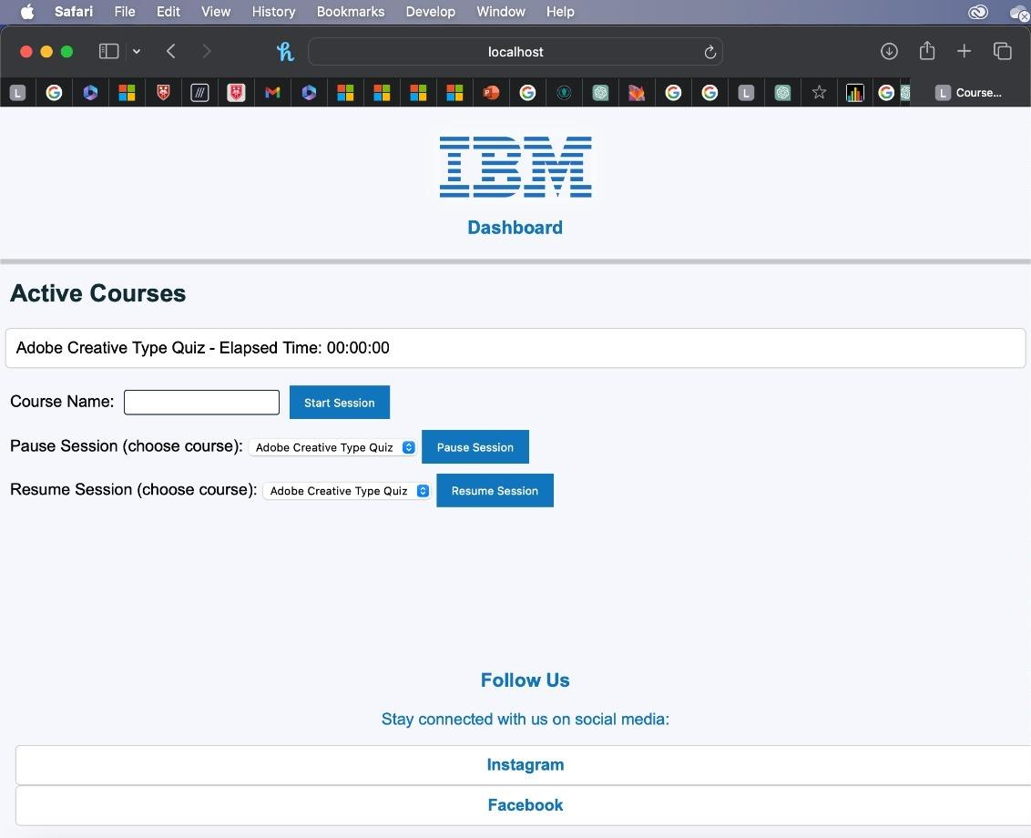

Figure 8- shows what happens when the user type in a course name and click the “Start Session”.

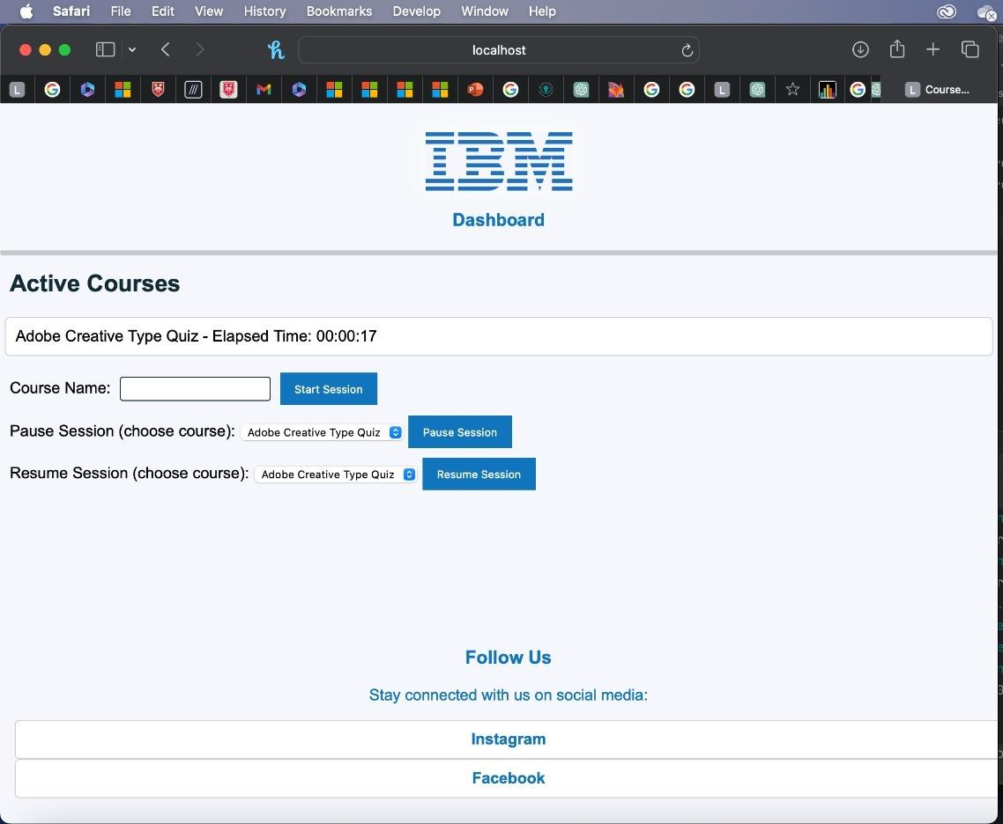

Figure 9- shows what happens after the user click the ‘Pause session’ button, it shows the timer going off and shows how much time it’s been.

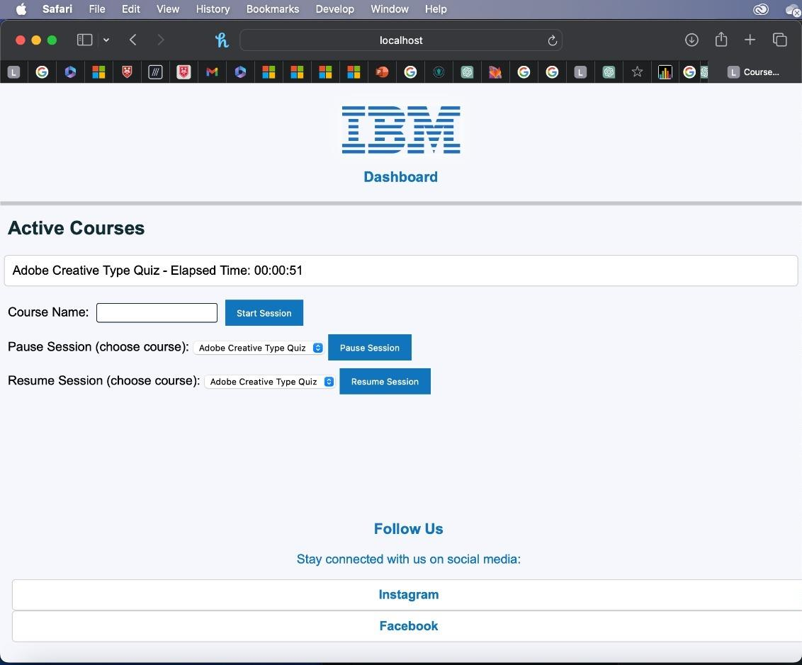

Figure 10- shows what happens when the user clicks the ‘Resume Session’ button

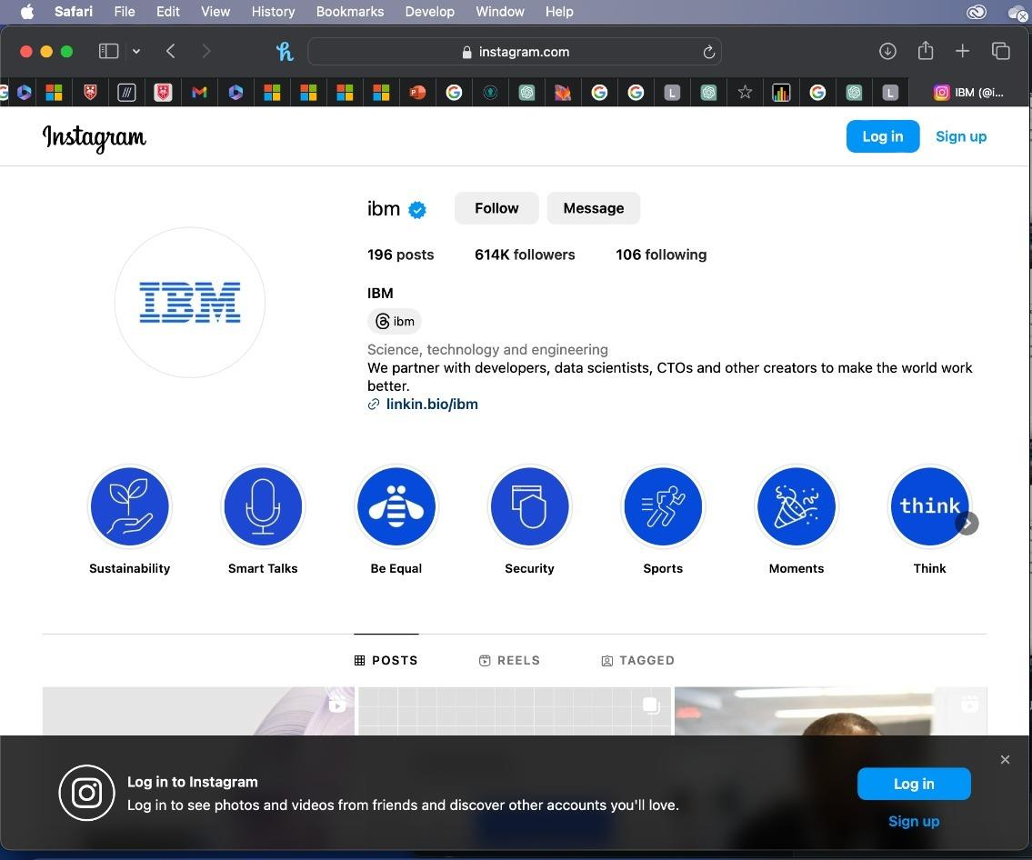

Figure 11- shows what happens when the user clicks on the Instagram link in the footer.

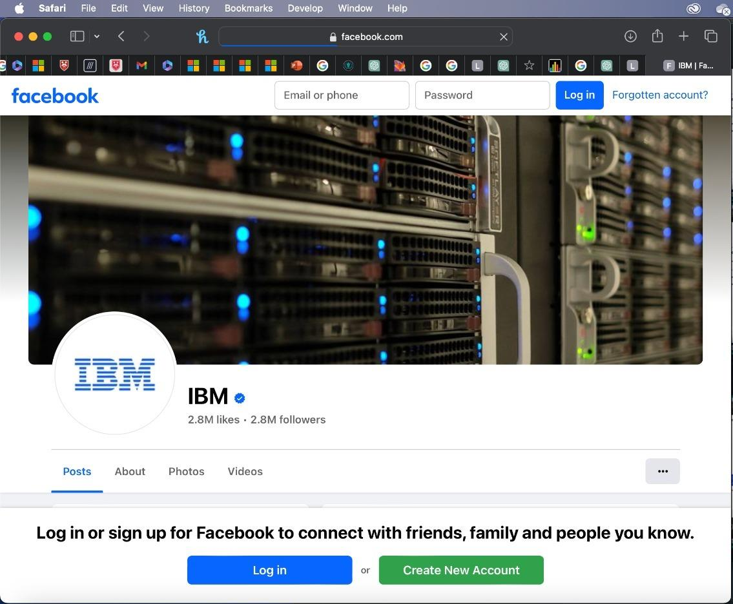

Figure 12- shows what happens when the user clicks on the Facebook link in the footer.

Completing Courses:

This part of the webapp allows you as a user to confirm the completion of your course from the dashboard.

Figure 13- dashboard page

As you can see there is a “complete” button on the right most part of the dashboard next to the “status” button. Clicking this button will reload the page, remove the course from the table and add 1 to your total tally of courses completed.

Figure 14- user page before the complete button is pressed.

Figure 15- user page after the complete button is pressed.

Leader board:

This part of the webapp shows the users rank against all the registered users. Newly registered players will appear on this leader board at any time.

Figure 16- showing the leader board after new user "Moksh" has registered.

After the user completes a course the number of their “courses completed” will update instantly in real time.

Figure 17- leader board after "Moksh" completed 1 course.

Any user that completes a course will have their score updated and if their score surpasses anyone higher than them, they will be able to climb the leader board in real time.

Figure 18- leader board after "Moksh" completed 5 courses in total.

As you can see player “Moksh” went from 4th on the leader board with 0 courses completed to 3rd on the leader board after completing 5 courses overtaking player “Adam”.

Badges:

As a user, you will be awarded badges as you complete more courses. These badges will be shown in your user page.

Figure 19- shows badges for completing 1 and 5 courses on user page.

Progress Bars:

As a user, you will be able to track 2 measurements of your progress. The first measurement being the overall progress you have made regarding completing all courses. This is shown through a main progress bar at the top of the dashboard page and user page. This bar tracks the percentage of completed courses.

Figure 6- shows the progress bar when no courses have been completed

Figure 7- shows progress bar after some courses have been completed

The second progress measurement is your individual course progress. Next to the course names with the other information you can see a percentage bar showing how much of the course you have completed and a value to show the exact completion percentage.

Figure 8-shows the individual course completion percentages

Friends:

Users are able to add other users on the platform as friends in order to compete against each other on the friend leaderboard. Users can add friends through the search bar located on their profile, or by going on the friend’s public profile and clicking ‘Add Friend’ there. The user can accept friend requests shown in the ‘Incoming’ section and remove friend requests shown in the ‘Outgoing’ section.

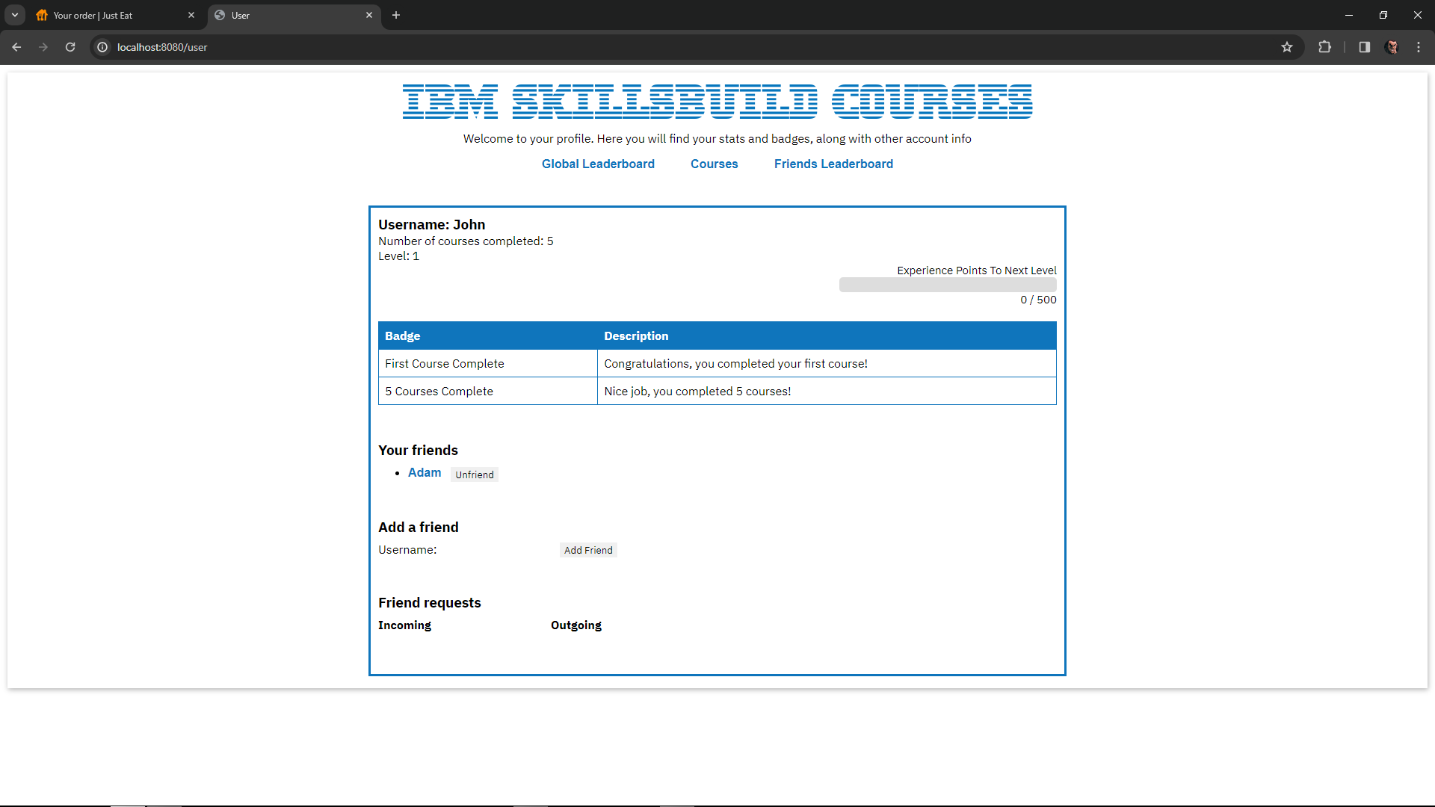*Figure 9 shows the user’s profile containing information about friends*

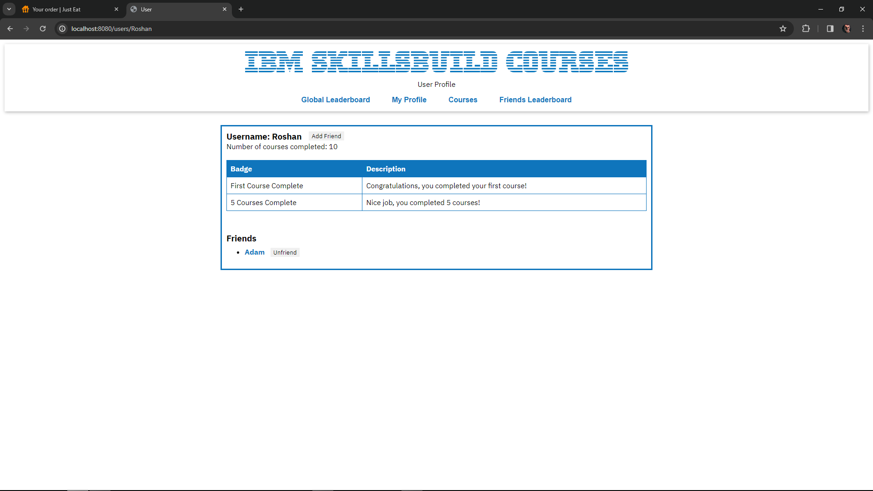

*Figure 10 shows a user’s public profile*

User’s public page displays information about user such as badges and friends. There is also a button next to the user’s name – if the current user is not their friend it will display ‘Add Friend’, otherwise it will be ‘Unfriend’.

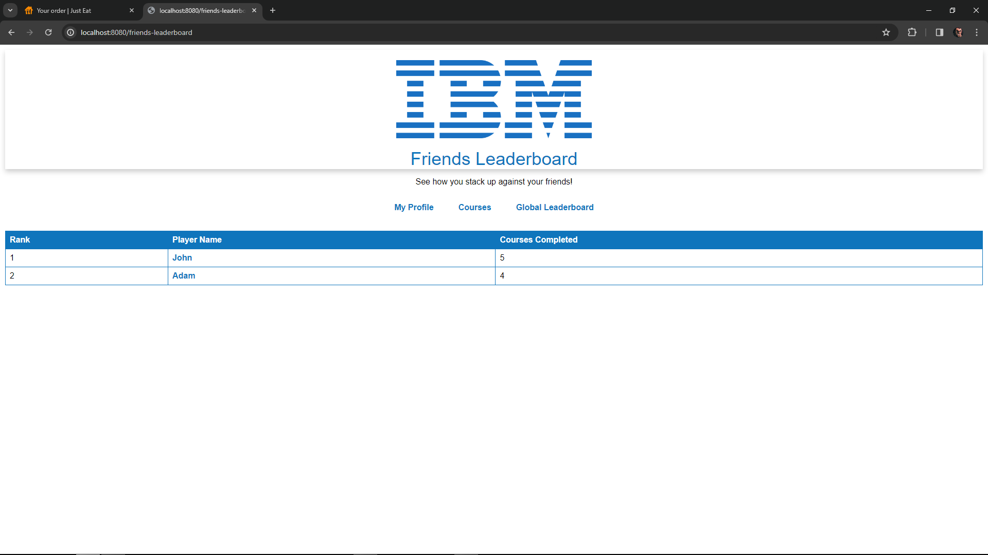

*Figure 11 shows the friends leaderboard*

The friend leaderboard is similar to the global leaderboard, but it only displays friends of the current user.

Comment and Rating:

As a user, you can leave comments and ratings for courses to suggest improvements to completed courses or encourage others to complete them.

Figure 12-comment and rating page

Figure 13- Shows that a course has been added to the list

When the user clicks the complete button after completing the course, the completed course is added to the course name on the comment page. If you do not complete the course, the course will not be added to the course name list.

Figure 14- Shows a pop-up error message when submitting an empty field

Figure 14- Shows a pop-up error message when writing under 1

Figure 14- Shows a pop-up error message when writing over 5

Figure 14- Shows a pop-up error message when inputting a non-numeric character

Ratings can be selected from 1 to 5.

* If you click the submit button without writing a rating, a message will appear prompting you to provide a rating.
* If you enter 0, a message will prompt you to enter a number greater than or equal to 1.
* If you enter a number greater than 5, a message will prompt you to enter a number less than or equal to 5.
* If you input a non-numeric character, a message will appear asking you to input a number.

Figure 15- Shows a pop-up error message when submitting empty comment

If you press the submit button without leaving any comment in the comment window, a message asking you to write a comment will be displayed below the comment window.

Figure 15- Shows the comment and rating

After you write a comment, you can see the user name, course name, rating, and comment. You can also continue to leave comments.

Profile Customisation

As a user, you can create personal changes to your profile such as an alias, a bio and a profile picture.

Figure 16- Shows the profile blank

If you press the edit profile button at the top then you can make changes to your user, profile.

Figure 17- Shows the edits to the bio, the alias and an added profile picture

Once your changes have been made, press the save changes button and they will be reflected on your profile page.

Figure 17- Shows the edits to the reflected changes